

THE PROBLEM:
Hunger exists in Livingston County.
An estimated 32,000 neighbors are living at or near poverty in Livingston County, or nearly 18% of total population.
High risk populations, those with the lowest levels of education and income, have significantly increased occurrences of high cholesterol, hypertension, obesity, and diabetes.
The Michigan Blueprint to End Hunger, a study released by the Food Bank Council in 2007, identified a 51% gap in Livingston County - in food available relative to the needs of local families and individuals living in poverty.

THE SOLUTION:
As local demand for food assistance continued to rise, community partners came together and commissioned a local study to better understand hunger and food security in Livingston County and to improve food security and access for our neighbors who are at risk.
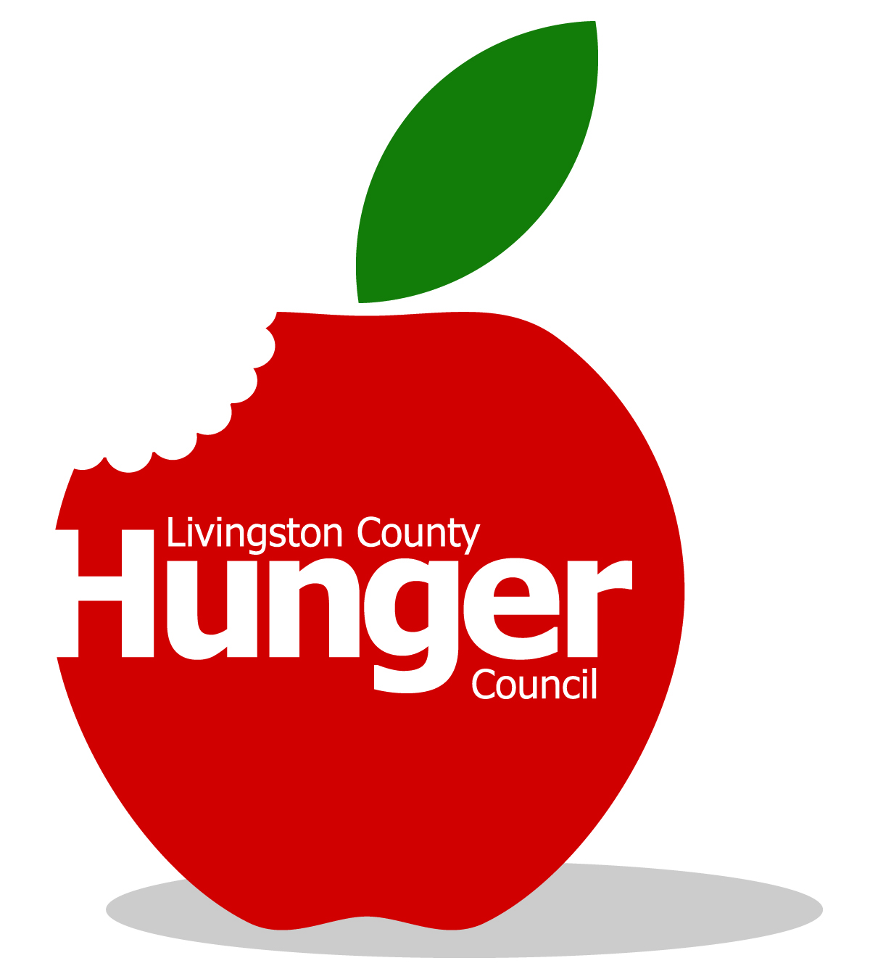
A cross-sector food security council, called the Livingston County Hunger Council, was born in 2009 to tackle local hunger issues, eliminate the 51% hunger gap within five years, and improve access to quality, nutritious food. Four committees were created to tackle these first strategies:

- Optimize government food programs.
- Strengthen private and charity food programs.
- Empower people to make healthy food choices.
- Develop community-based solutions to eliminate hunger.

THE RESULTS:
- Gleaners/OLHSA partnership (the first in the state) has improved accessibility, delivery, and efficiency across emergency and commodity food programs.
- Expanded Summer Lunch Bunch program to serve more children.
- Established a county-wide food pantry network.
- Our four community gardens produced over 10,000 pounds of produce in the first season.
- Raised the federal Food Assistance Program utilization from 27.1% in 2007 to 51.6% in 2010.
- Created and distributed a generic free & reduced lunch application for all county schools.
- Raised community awareness of the hunger problem in Livingston County.
- Secured its first grant award; and submitted a large 3-year grant application to USDA, which is pending.
- Provided a total of 3,855,423 additional meals over 2009 levels – reducing the hunger gap by almost 77%.
Call 810-494-3000 to get involved and help eliminate hunger in Livingston County.

